Assignment 2

**Course** : ELEC 451

**Instructor** : Dr. Martin Ordonez

**TA’s** : ​ Franco Degioanni

Daniel Hsu

Lucas Sinopoli

|  |  |
| --- | --- |
| **Student** | **Student Number** |
| Cole Shanks | 54950860 |

Table of Contents

1. [PWM DC/AC Converter (Inverter)](https://docs.google.com/document/d/1zi1UmuwrZgd3v3AV9W8dH9qYhFg-cFiDoSRrMxWIbkg/edit#heading=h.b64ytbc6kxqu)  1
   1. Part A 1
   2. Part B 2
   3. Part C 2
   4. Part D 2
   5. Part E 3
   6. Part F 4
      1. Part i 4
      2. Part ii 4
2. DC/DC Isolated Power Supply using a Full-Bridge Converter 7
   1. Part A 7
   2. Part B 8
   3. Part C 8
   4. Part D 9
   5. Part E­­­­­­ 11
3. [**PWM DC/AC Converter (Inverter)**](https://docs.google.com/document/d/1zi1UmuwrZgd3v3AV9W8dH9qYhFg-cFiDoSRrMxWIbkg/edit#heading=h.b64ytbc6kxqu)

Switch-mode DC-to-AC inverters are useful for generating an AC sinusoidal output whose magnitude and frequency can be controlled. They are commonly used in AC motor drives and uninterruptable AC power supplies.

* 1. **Part A**

The topology chosen was a Single-phase Full Bridge Inverter with Bi-Polar switching.

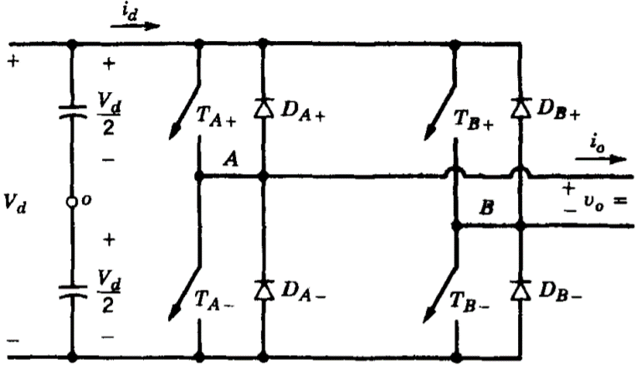

Figure 1. Single-phase Full Bridge Inverter

This topology was selected because:

* Full Bridge does not require that the input voltage be split into two halves with capacitors. If a half-bridge circuit was assembled, the input voltage would need to be doubled. This increases the current and the strain put on the MOSFETS.
* Bi-Polar switching was selected because it is simpler to implement and is sufficient for the requirements listed.

An equivalent circuit was built in PSIM using triangular wave and sine wave voltage sources that were then inputted to a comparator to achieve the necessary modulation. 4 MOSFETs were used as switches and are labelled T­­A+, T­­A-, T­­B+, and T­­B- respectively.

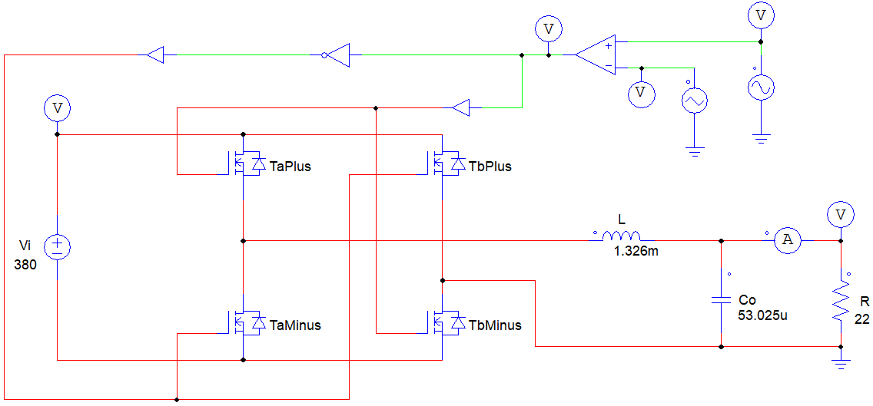

Figure 2. Single-phase Full Bridge Inverter PSIM

* 1. **Part B**

The modulation index $ma$ to achieve the required output voltage can be calculated as follows.

$${Vo}_{RMS}=\frac{V_{control}}{V_{tri}}*Vi$$

Where $ma=\frac{V_{control}}{V_{tri}}$

Therefore,

* 1. **Part C**

To obtain the desired output current, the load resistor $R_{L}$ must be selected appropriately.

The desired output current is

So,

* 1. **Part D**

Next, we find the filter inductance $L$ and capacitor $C$ for a characteristic impedance $Z_{o}$ of 5 $Ω$ and a cut-off frequency $F_{o}$ of 600Hz.

$Z_{o}=\sqrt{\frac{L }{C }}$, $F_{o}=\frac{1}{2π\sqrt{LC}}$

$$Eq1 5Ω=\sqrt{\frac{L }{C }}$$

$$Eq2 600Hz=\frac{1}{2π\sqrt{LC}}$$

Solving these two equations for the two unknowns yields

* 1. **Part E**

It can be seen from the waveforms below how using PWM controlled modulation can yield the desired sinusoidal AC output. Some key observations obtained from these simulations include:

* The Low-Pass filter on the output successfully takes the modulation waveform, filters out the high frequencies and keeps the average value information. The result is a smooth sinusoidal output for both the voltage and current with a fundamental frequency of 50Hz.
* If the switching frequency is higher. The output will be less distorted by harmonics and will retain a smoother sinusoidal shape. The trade-off is higher switching losses. In the case of this circuit, 20kHz is sufficiently high to yield a good AC output.
* The inductor current ripple (measured at the zero-crossing) is approximately 6.6V.

Simulation (Output Voltage)

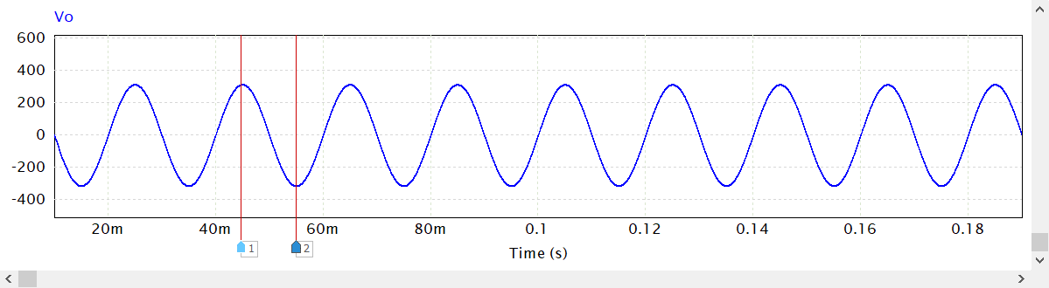

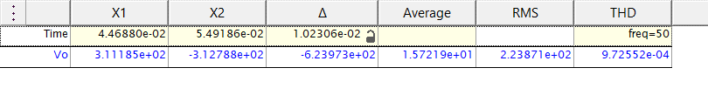

Waveform 1. Output Voltage

Simulation (Output Current)

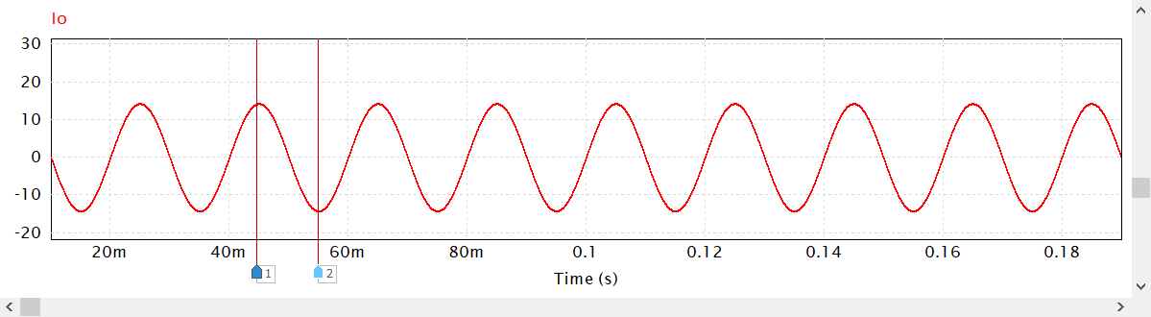

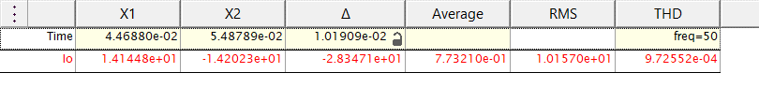

Waveform 2. Output Current

Simulation (Inductor Current Ripple)

Note - measured at the zero crossing.

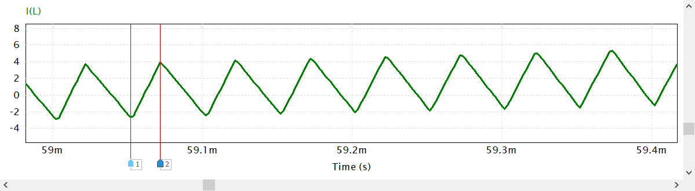

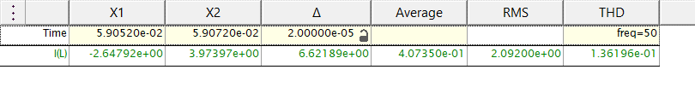

Waveform 3. Inductor Current Ripple

* 1. **Part F**

The filter can be redesigned for cut-off frequencies of 1200Hz and 300Hz.

* + 1. **Part i**

Solving these two equations for the two unknowns yields

* + 1. **Part ii**

$$Eq1 5Ω=\sqrt{\frac{L }{C }}$$

$$Eq2 300Hz=\frac{1}{2π\sqrt{LC}}$$

Solving these two equations for the two unknowns yields $L=2.653mH, and C=106.103uF$

The FFT Analysis provides useful insights into the frequency domain and how the filter is performing. Some key observations include:

* The first key point in the FFT waveform is at 50Hz This is the fundamental frequency of the sine wave and it is represented by the spike seen at 50Hz in the waveforms. The cut-off frequency needs to be higher than this so that the fundamental frequency is not filtered out.
* The second key location is at 20kHz. This is the switching frequency. The cut-off must be before this point to ensure that harmonics from 20kHz are not allowed to pass through the filter.

FFT Analysis (Output Voltage) for $F_{o}=$ 600Hz

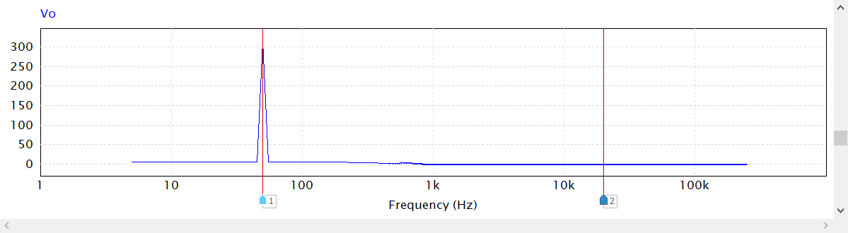

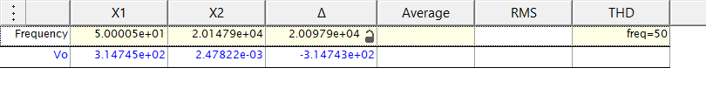Waveform 4. Output Voltage FFT Analysis with a cut-off frequency of 600Hz

FFT Analysis (Output Voltage) for $F_{o}=$ 1200Hz

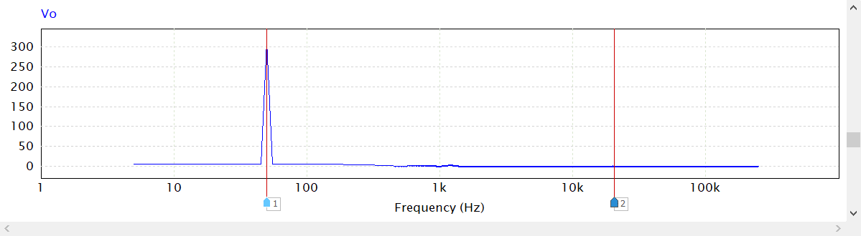

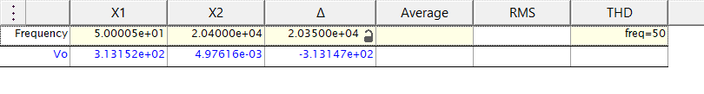Waveform 5. Output Voltage FFT Analysis with a cut-off frequency of 1200Hz

FFT Analysis (Output Voltage) for $F_{o}=$ 300Hz

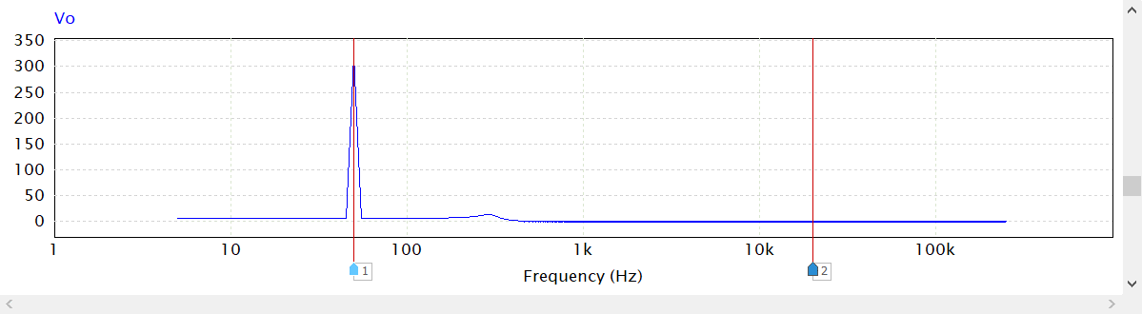

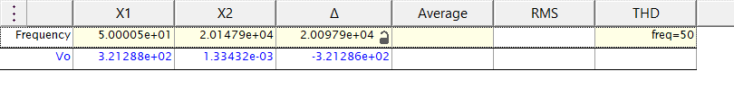Waveform 6. Output Voltage FFT Analysis with a cut-off frequency of 300Hz

1. **DC/DC Isolated Power Supply using a Full-Bridge Converter**

An equivalent circuit was built in PSIM using a square wave generator at a frequency of 150kHz. 4 MOSFETs were used as switches and are labelled T­­A+, T­­A-, T­­B+, and T­­B- respectively. A

1-phase 3-winding transformer was used to step down the voltage.

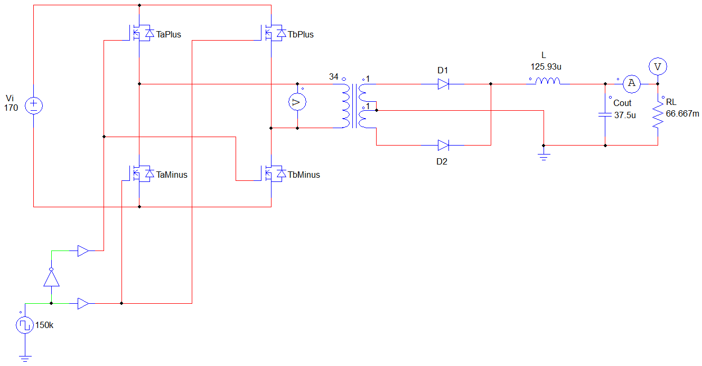

Figure 3. Isolated Power Supply using a Full-Bridge Converter PSIM

* 1. **Part A**

From viewing the circuit, it can be seen that there will be two distinct states for the voltage that $V_{L}$ sees across its terminals. When it’s the on state for the positive forward voltage

$$V_{L}=\frac{N_{S}}{N_{p}}V_{i}-V_{o}$$

And when its in the off state

$$V_{L}=-\frac{N_{S}}{N_{p}}V_{i}$$

By equating these two equations we obtain

$$\frac{N_{S}}{N_{p}}V_{i}-V_{o}=-\frac{N_{S}}{N_{p}}V_{i}$$

Then, remembering that the switching is controlled by the duty cycle

$$V_{o}=2\frac{N_{S}}{N_{p}}D*V_{i}$$

Therefore the gain equation is

$$\frac{V_{o}}{V_{i}}=2\frac{N_{S}}{N_{p}}D$$

The voltage needs to be stepped down from 170 to 5. This requires a turns ration of 34:1

$$D=\frac{V_{o}}{V_{i}*2}\frac{N_{p}}{N_{s}}$$

$$D=\frac{5}{170*2}*\frac{34}{1}$$

Therefore the duty cycle is

* 1. **Part B**

To obtain the desired output current, the load resistor $R_{L}$ must be selected appropriately.

The desired output current is

So,

* 1. **Part C**

The value for the filter inductor and capacitor can be calculated from the following equations.

$$ΔVo=\frac{{Δi}_{L}}{8Cf_{sw}}$$

$$C=\frac{{Δi}_{L}}{8ΔVof_{sw}}$$

$$C=\frac{2.25}{8*\left(0.05\right)150e3}$$

$$C=37.5uF$$

Then, for the inductor

* 1. **Part D**

The waveforms below demonstrate how the calculated circuit parameters implemented in the circuit operate with a high degree of accuracy. The output does not exactly match the target due to resistive drop and leakage in the transformer. However, the results are very close. Some key observations obtained from these simulations include:

* Steady state voltage output approximately 5V (desired output voltage).
* Steady state current output approximately 75A (desired output current).
* Output voltage ripple is very low. Approximately 16.3nV which is well below the maximum voltage ripple of 50mV
* Inductor current ripple is very low. Approximately 1.5uA which is well below the maximum current ripple of 2.25A.

Simulation (Output Voltage)

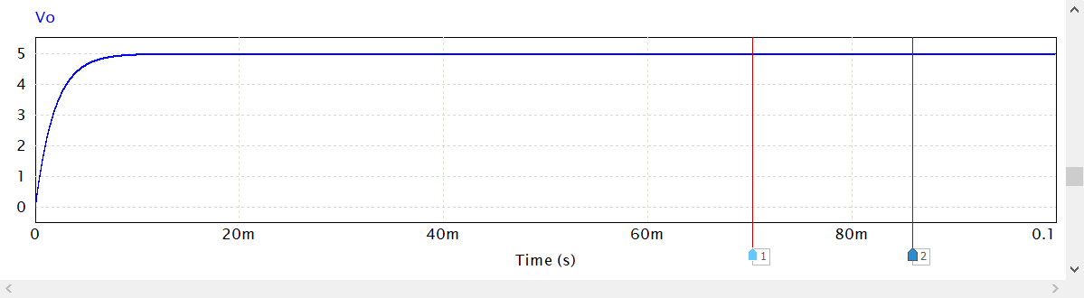

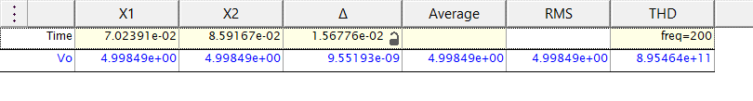

Waveform 7. Output Voltage

Simulation (Output Voltage Ripple)

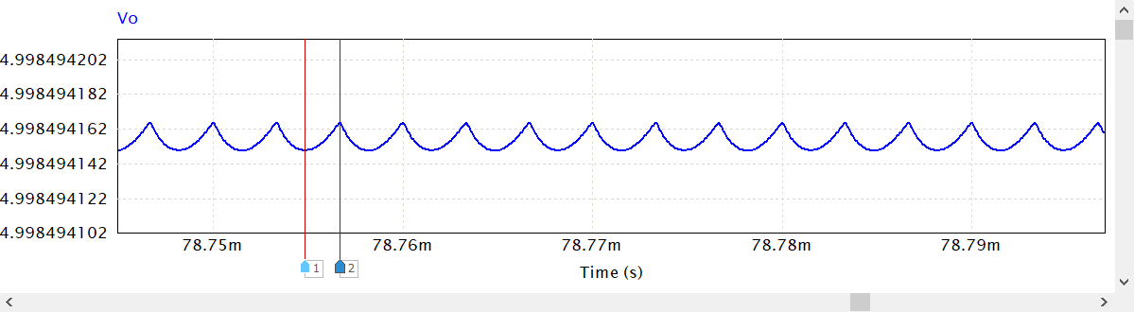

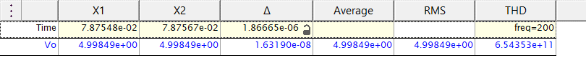

Waveform 8. Output Voltage Ripple

Simulation (Output Current)

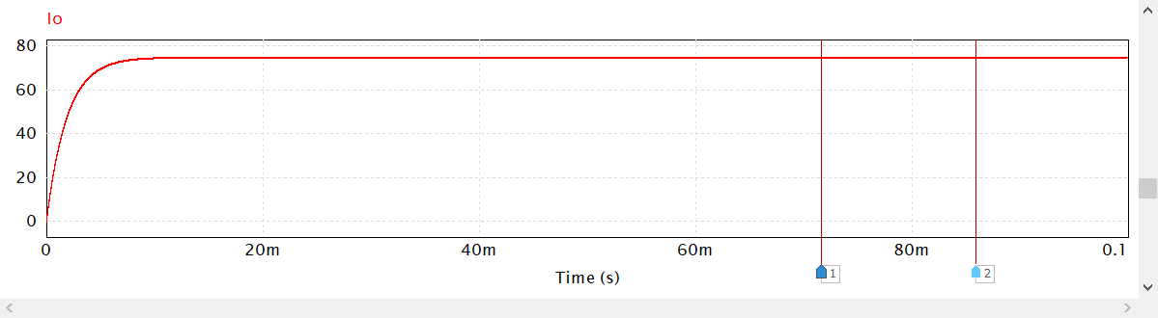

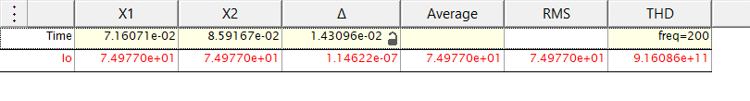

Waveform 9. Output Current

Simulation (Inductor Current Ripple)

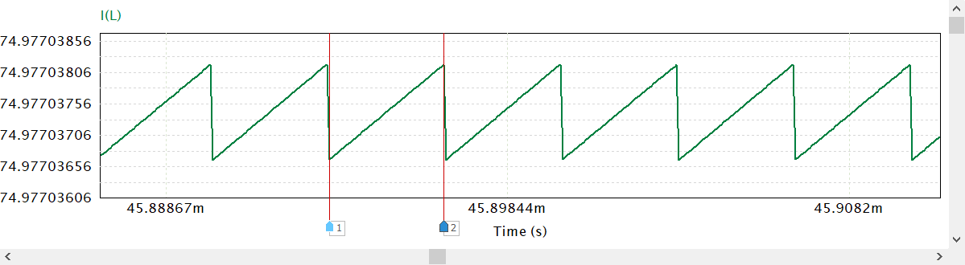

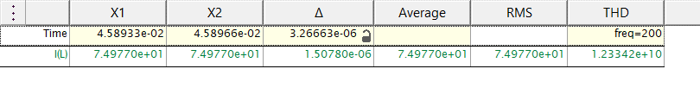

Waveform 10. Inductor Current Ripple

* 1. **Part E**

The ripple current through the inductor is very small so the point at which this converter enters the boundary region is when the output current is also very small. Therefore we need a large resistor for the load.

Through trial and error I was able to determine that the point at which this converter enters the boundary region is at approximately

$$R_{L}=220Ω$$

In this operating mode the current through the inductor is actually touching zero. On the boundary it is only touching the real line but in Discontinuous Conduction Mode there would actually be a set of times where no current is flowing through the inductor and it would flatline. This change in operating mode yields some interesting observations that can be seen in the waveforms. Some key observations include:

* The output voltage in steady state is below the desired 5V.
* There is a more significant output current ripple.
* The output current is very small due to the large resistor.
* The inductor current ripple is larger and it touches zero.

Simulation (Output Voltage)

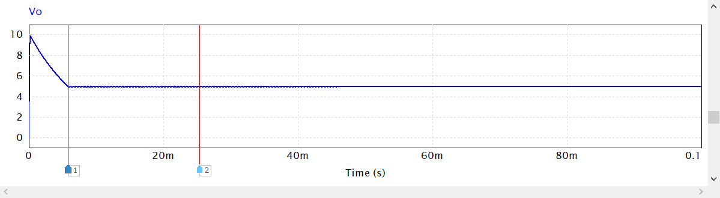

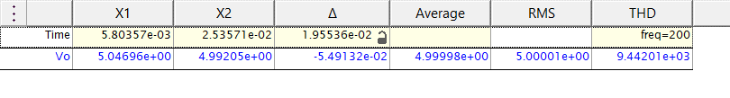

Waveform 11. Output Voltage (Boundary Conduction Mode)

Simulation (Output Voltage Ripple)

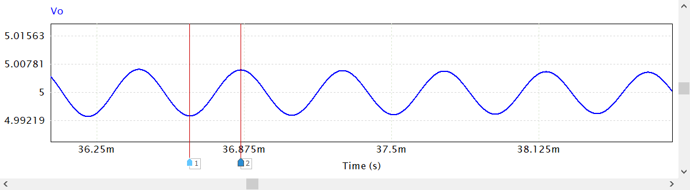

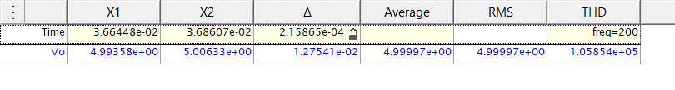

Waveform 12. Output Voltage Ripple (Boundary Conduction Mode)

Simulation (Output Current)

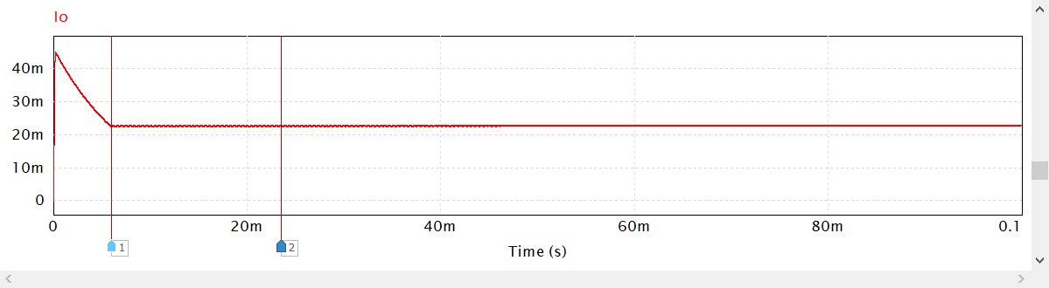

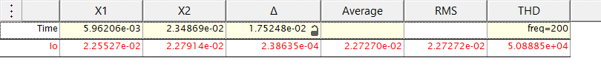

Waveform 13. Output Current (Boundary Conduction Mode)

Simulation (Inductor Current Ripple)

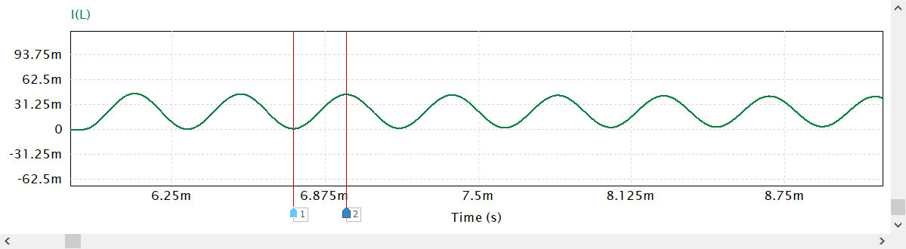

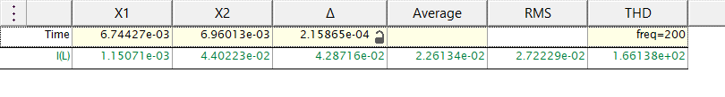

Waveform 14. Inductor Current Ripple (Boundary Conduction Mode)